Fruit Fly Trap
Construct a trap by placing a paper funnel (rolled from a sheet of notebook paper) into a jar which is then baited with a few ounces of cider vinegar. Place the jar trap(s) wherever fruit flies are seen. This simple but effective trap will soon catch any remaining adult flies which can then be killed or released outdoors.

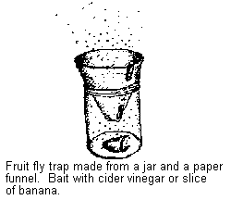

Source: University of Kentucky Entomology
http://www.uky.edu/Agriculture/Entomology/entfacts/struct/ef621.htm

